At first, I created new project at GitLab:

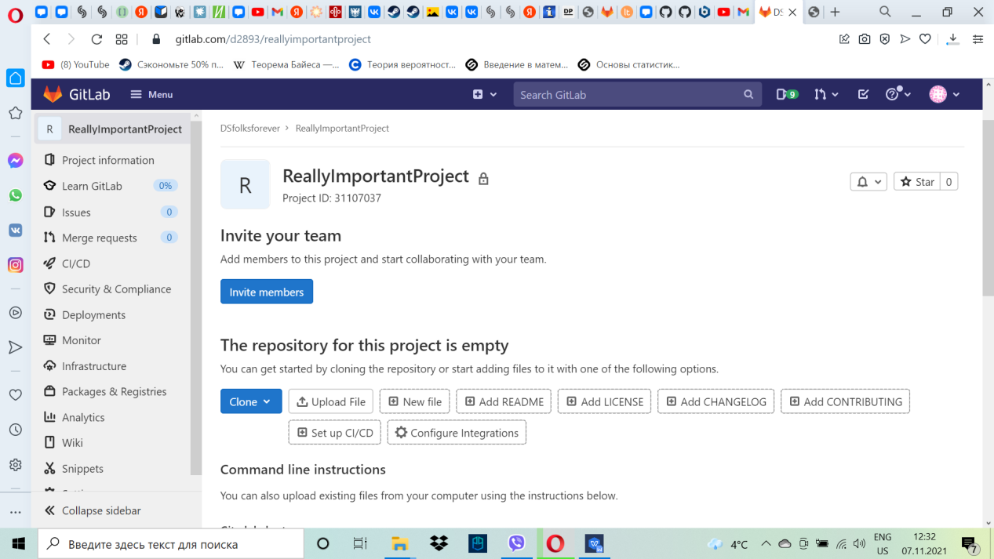

As you see, I have already cloned this project into my Git:

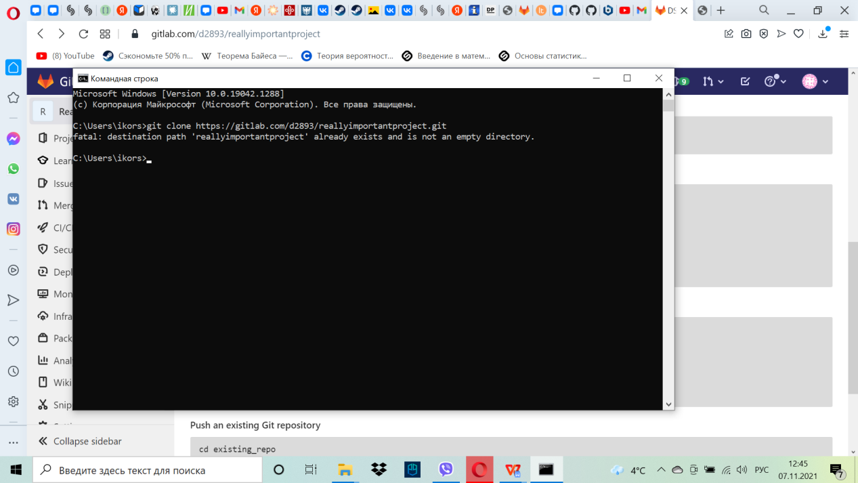

I uploaded files from <https://github.com/olindata/sample-gitlabci-cpp-project> to my GitLab Server:

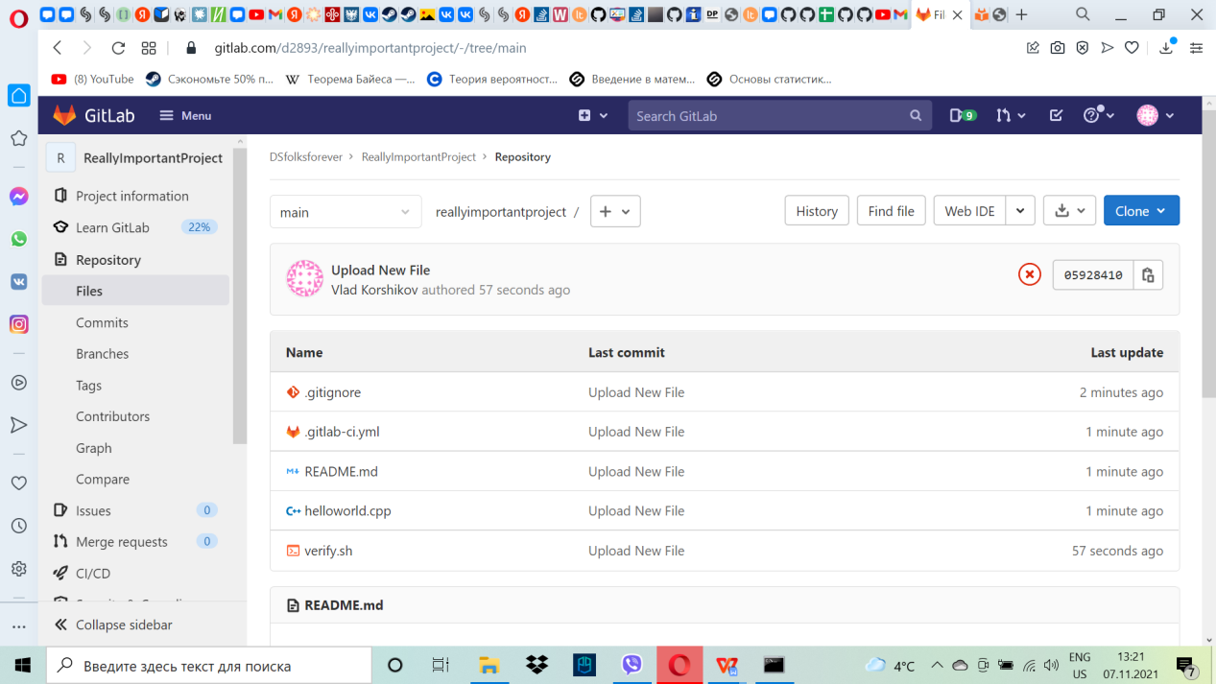

Creating SSH-key

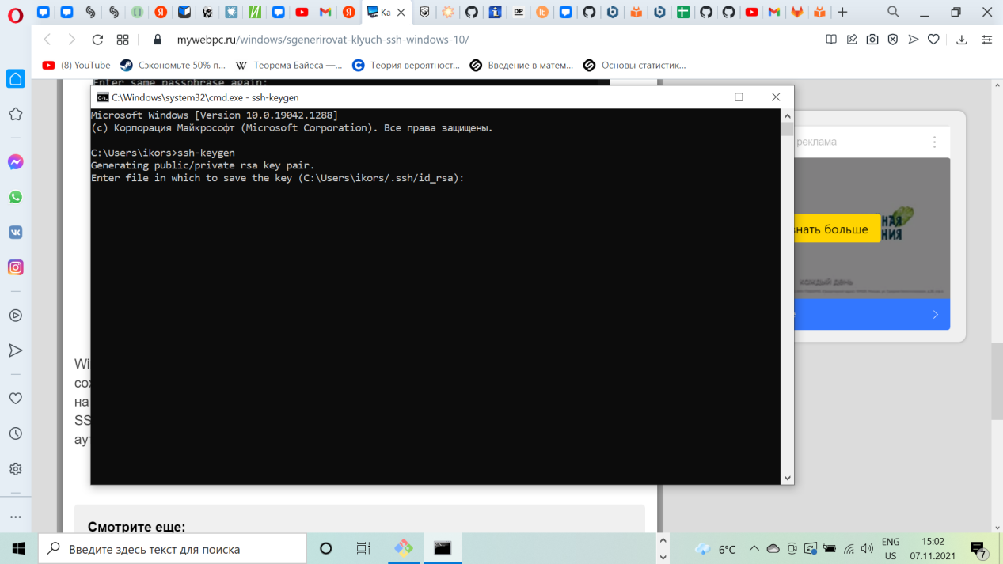

Adding SSH key:

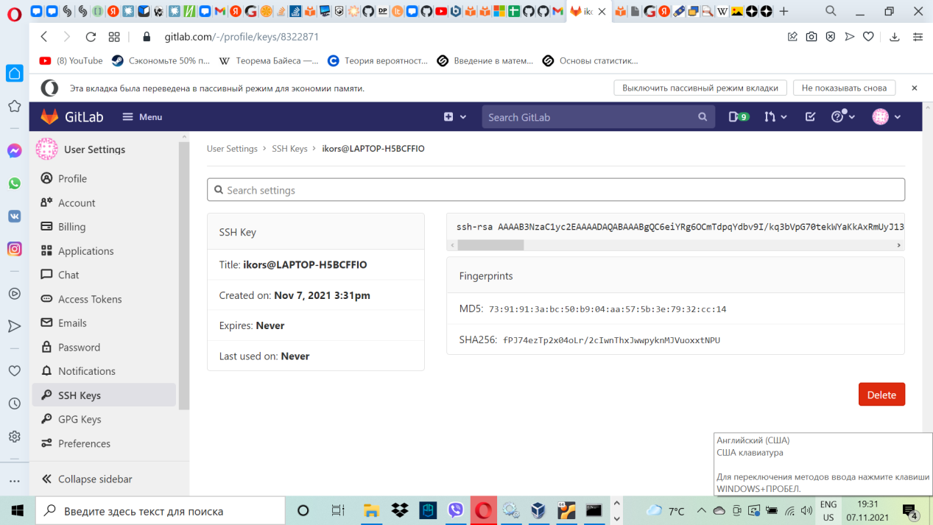

Installing GitLab Runner:

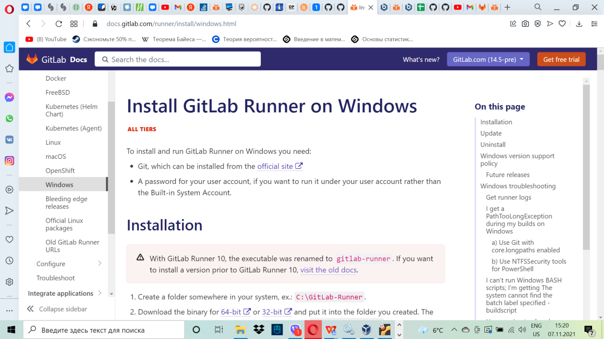

It’s time to open CI/CD

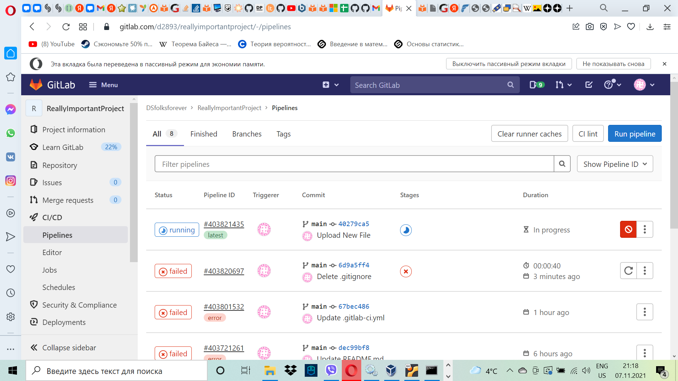

Edit .gitlab-ci.yml

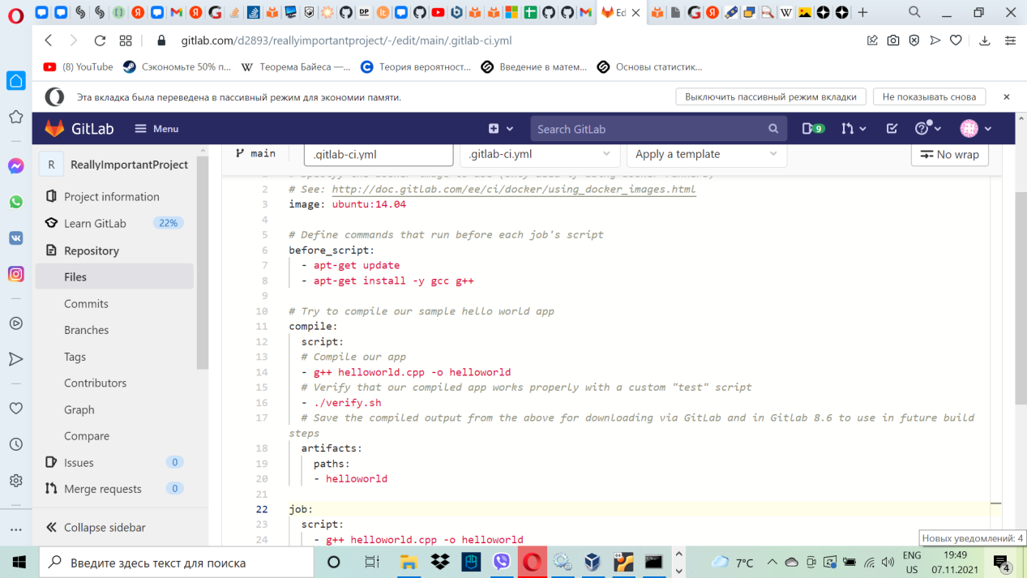

But everytime I’m trying to compiling this script, it’s end up with a mistake. Compilation failed. Even if I’m trying to do it in Ubuntu VM

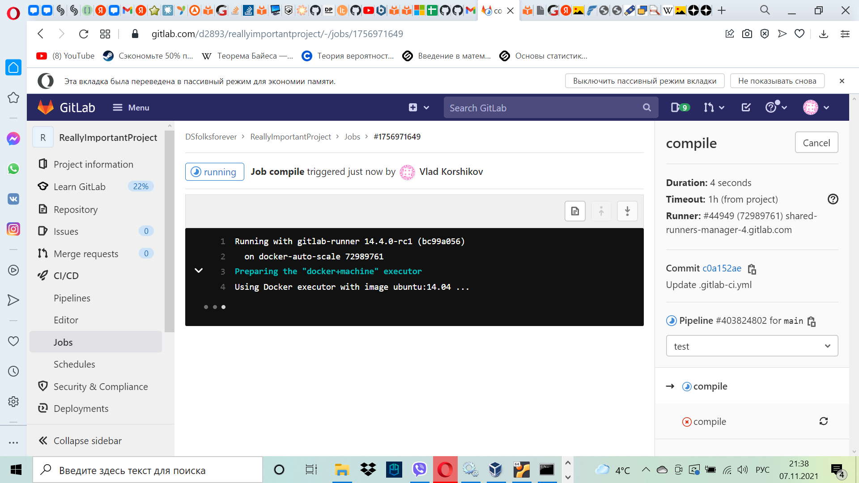

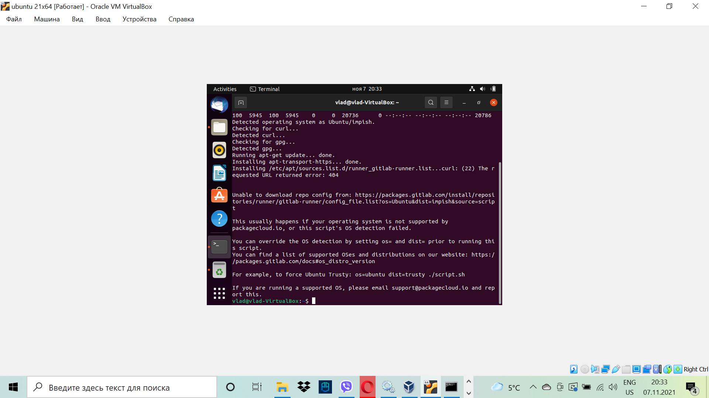

But, at least, I made every step in this lab, so, I made this Assignment properly